EB1/74409/24 GIDEON KORIR

EB1/74210/24 KAMAU WILFRED

EB1/74311/24 JOAN NDIGIRIGI

EB1/74346/24 TRACY JEPCHUMBA

EB1/74318/24 NICODEMUS MURITHI

EB1/74328/24 COLLINS KAHUNGO

EB1/74357/24 FABIAN MUNENE

HOSPITAL MANAGEMENT SYSTEM

1. System Description

1.1 Name of the System
Hospital Management System

1.2 Purpose of the System
The Hospital Management System is designed to efficiently manage hospital operations by organizing and storing essential data such as patient records, doctor details, appointments, treatments, and billing information.
The system aims to:
- Improve efficiency in handling hospital records
- Reduce manual paperwork and errors
- Provide quick access to patient and treatment information
- Enhance coordination between hospital staff

1.3 Main Users of the System
The system is used by different stakeholders within the hospital:
- Doctors – Diagnose patients and record treatments
- Nurses – Assist doctors and manage patient care
- Receptionists – Register patients and schedule appointments
- Administrators – Manage system operations and reports

1.4 Types of Data Stored
The system stores several categories of data:
- Patient Data
(Patient ID, Name, Age, Gender, Contact)
- Doctor Data
(Doctor ID, Name, Specialization, Contact)
- Appointment Data
(Appointment ID, Patient ID, Doctor ID, Date, Time)
- Treatment Data
(Treatment ID, Diagnosis, Prescription)
- Billing Data
(Bill ID, Patient ID, Amount, Payment Status)

2. Entity Relationship (ER) Modelling

2.1Attributes of Each Entity

PATIENT
- PatientID (Primary Key)
- Name
- Age
- Gender
- Phone

DOCTOR
- DoctorID (Primary Key)
- Name
- Specialization
- Phone

APPOINTMENT
- AppointmentID (Primary Key)
- PatientID (Foreign Key)
- DoctorID (Foreign Key)
- Date
- Time

TREATMENT
- TreatmentID (Primary Key)
- AppointmentID (Foreign Key)
- Diagnosis
- Prescription

BILL
- BillID (Primary Key)
- PatientID (Foreign Key)
- Amount
- PaymentStatus

2.2RELATIONSHIP
DOCTOR
DOCTORID
PHONE
SPECIALIZATION
NAME
treats
books
hass
APPOINTMENT
DOCTORID
APPOINTMENTID
DATE
TIME
PATIENTID
TREATMENT
TREATMENTID
APPOINTMENTID
DIAGNOSIS
PREBSCRIPTION
PATIENT
NAME

AGE
GENDER
PATIENTID
PHONE NUMBER
DOB
PAYMENT
PATIENTID
PAYMENTID
AMOUNT
PAYMENTSTATUS
makes

3. RELATIONAL MODEL

3.1 PATIENT TABLE

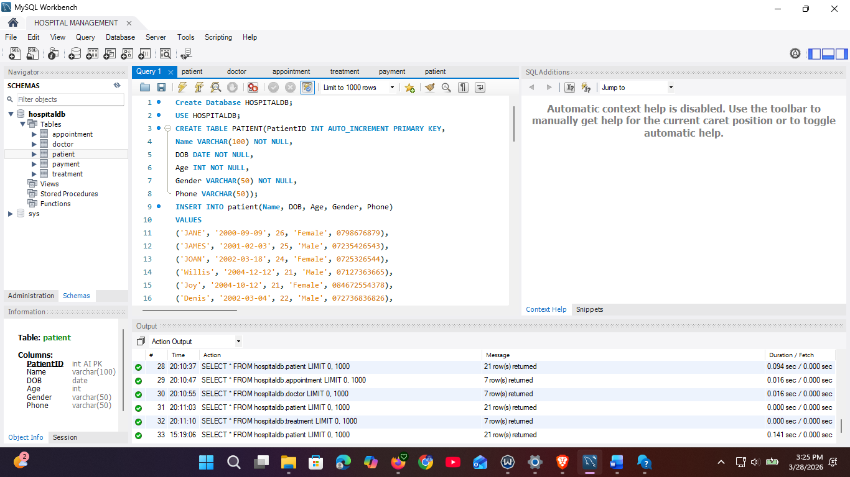

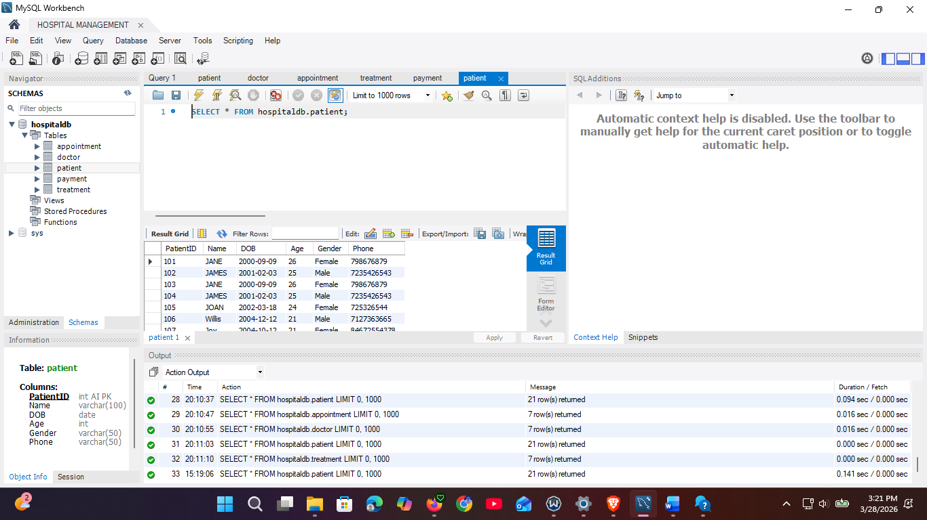

3.2 DOCTOR TABLE

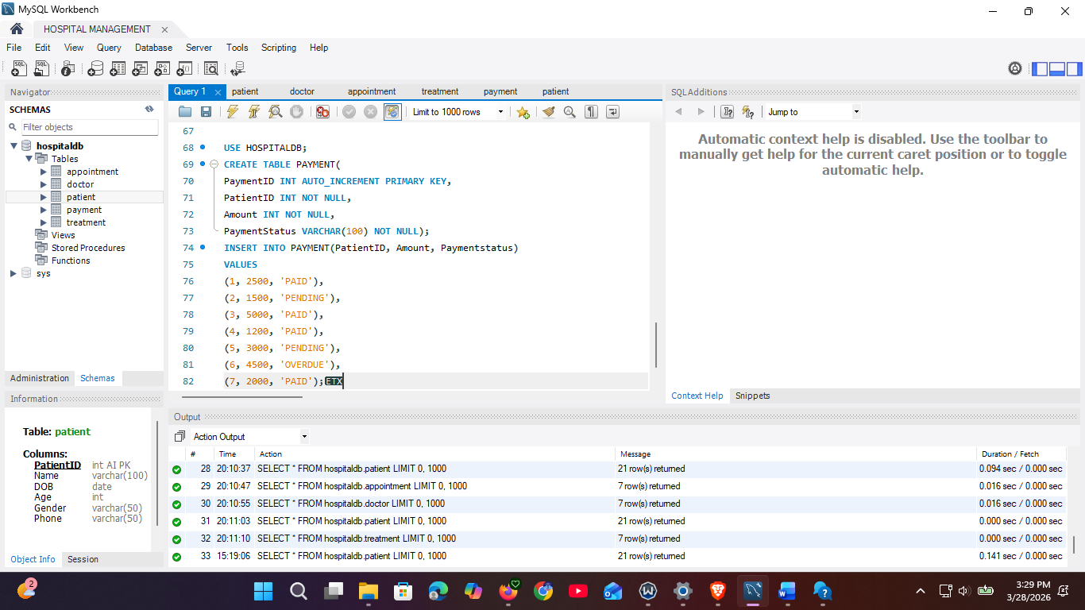

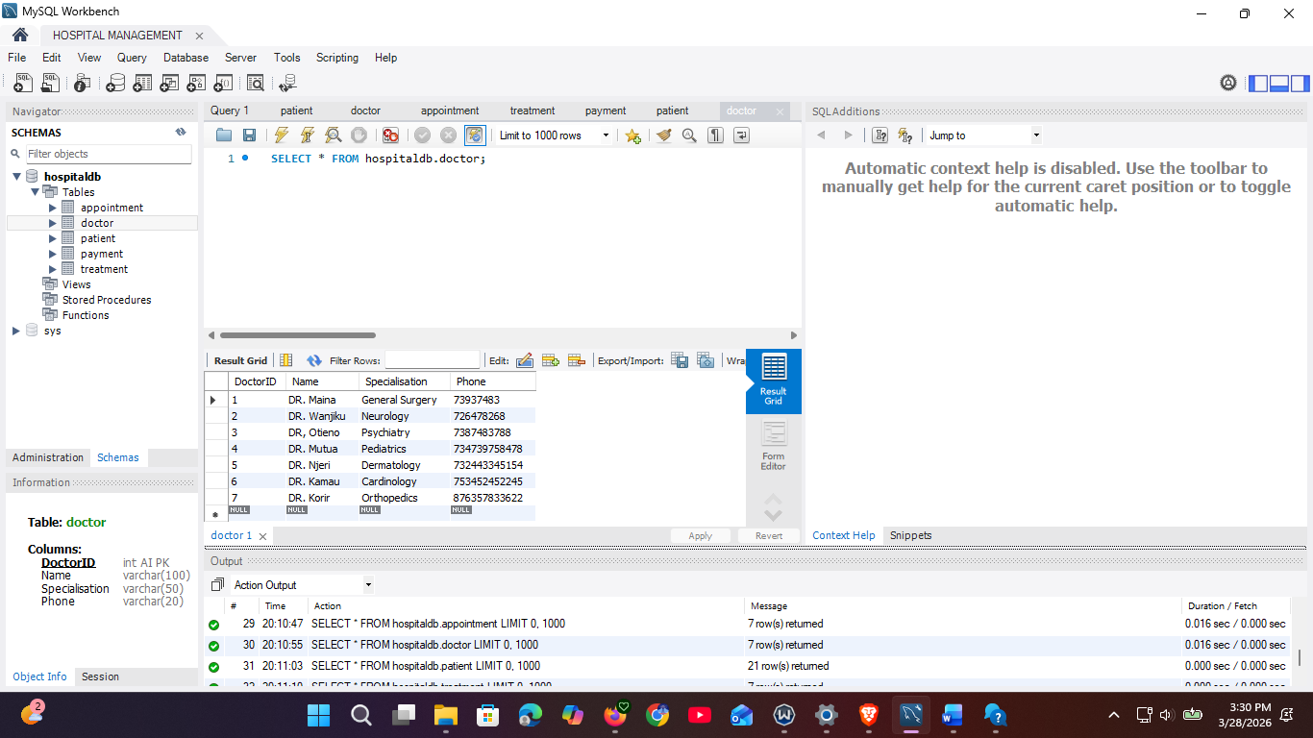

3.3 APPOINTMENT TABLE

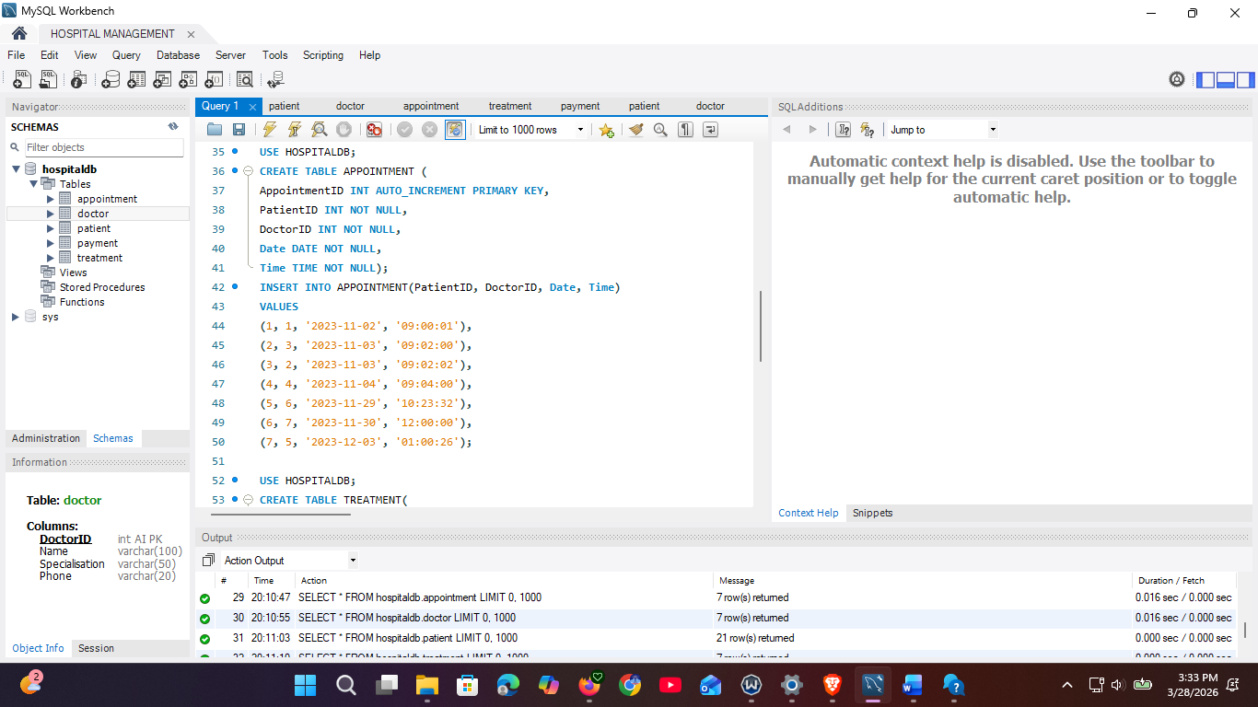

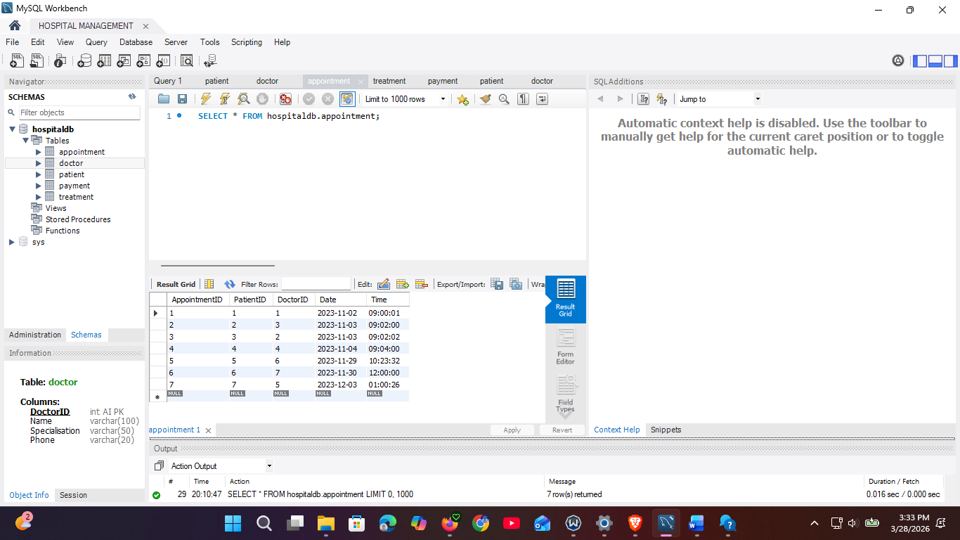

3.4 TREATMENT TABLE

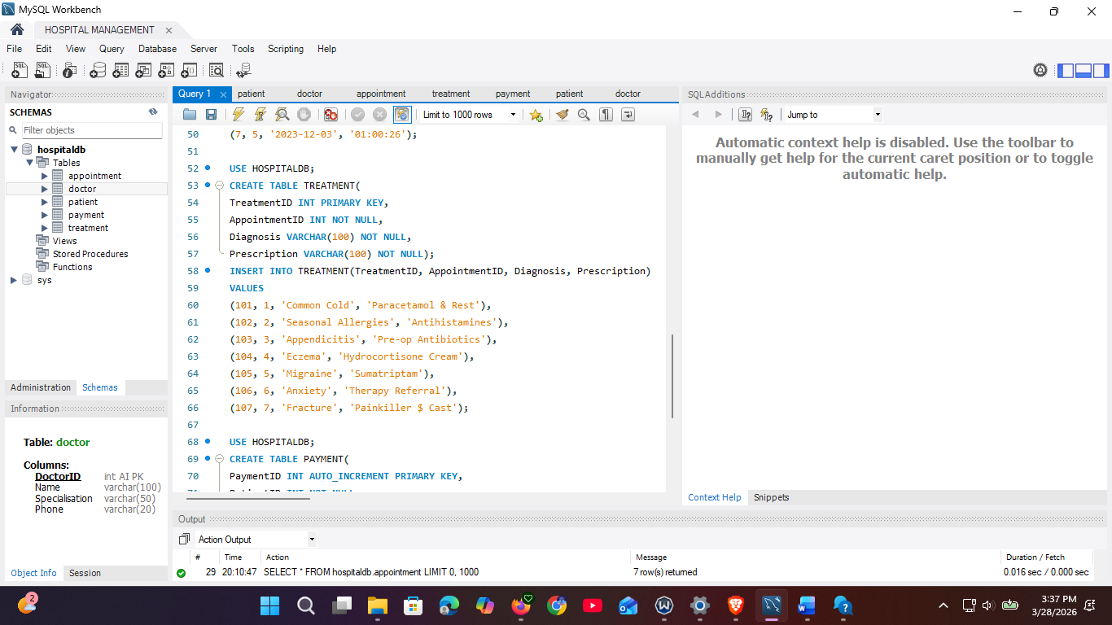
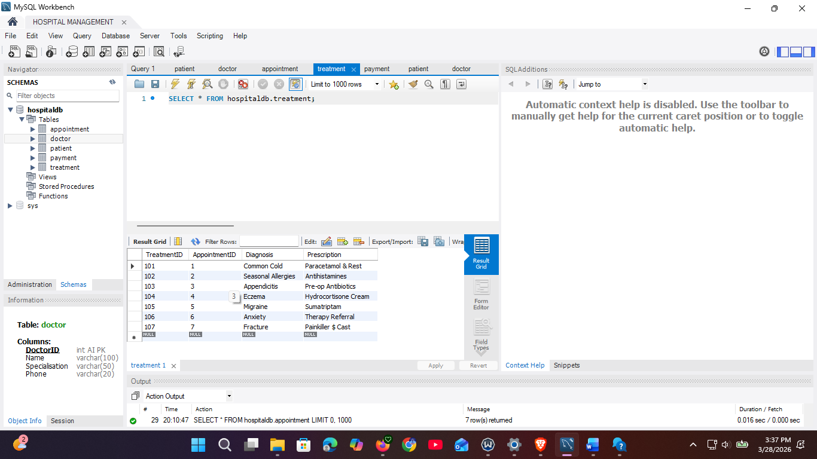

3.5 PAYMENT TABLE

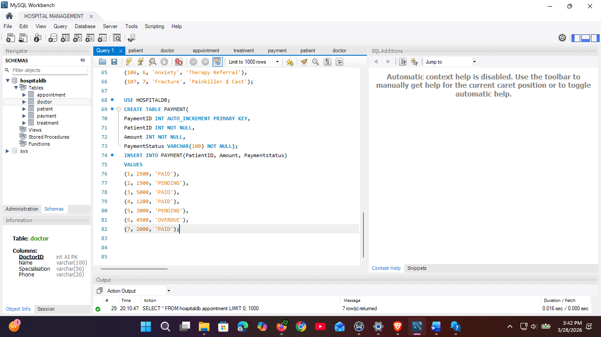

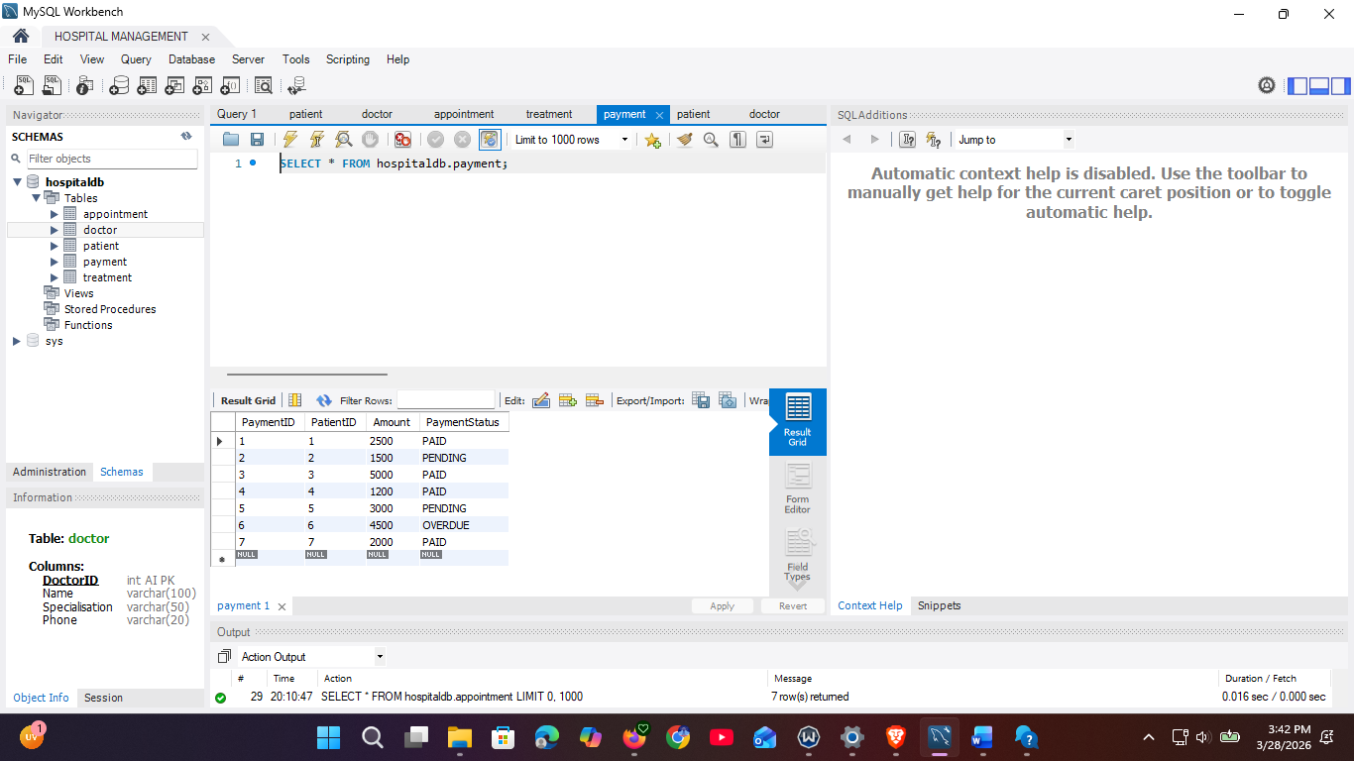

4.1 USE SELECT STATEMENT

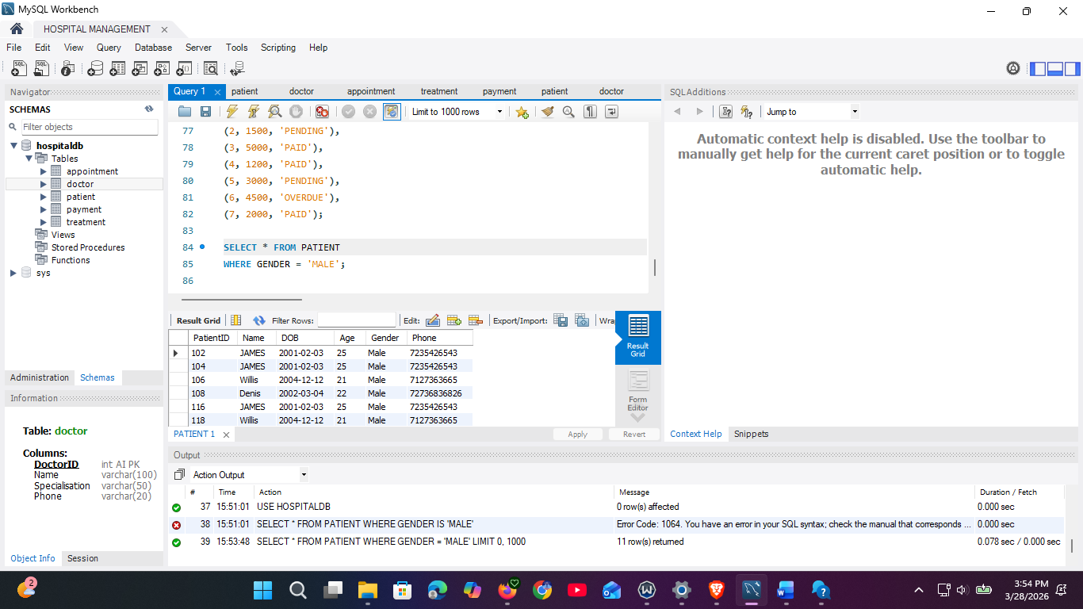

4.2 USE ORDER BY STATEMENT

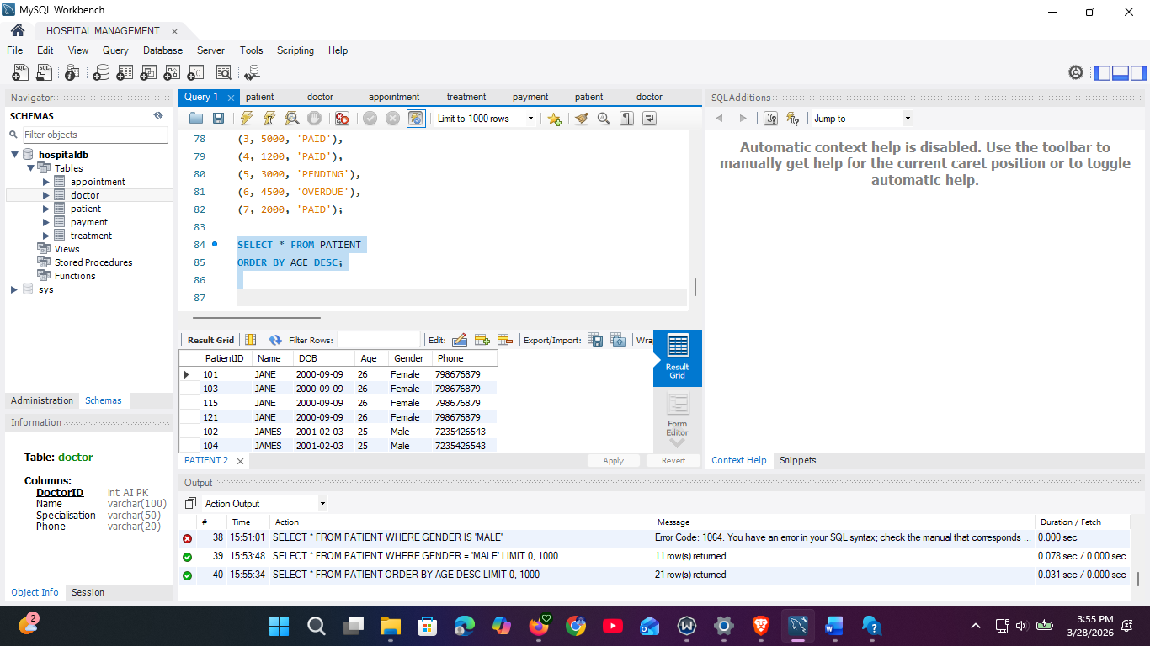

4.3 USE OF UPDATE
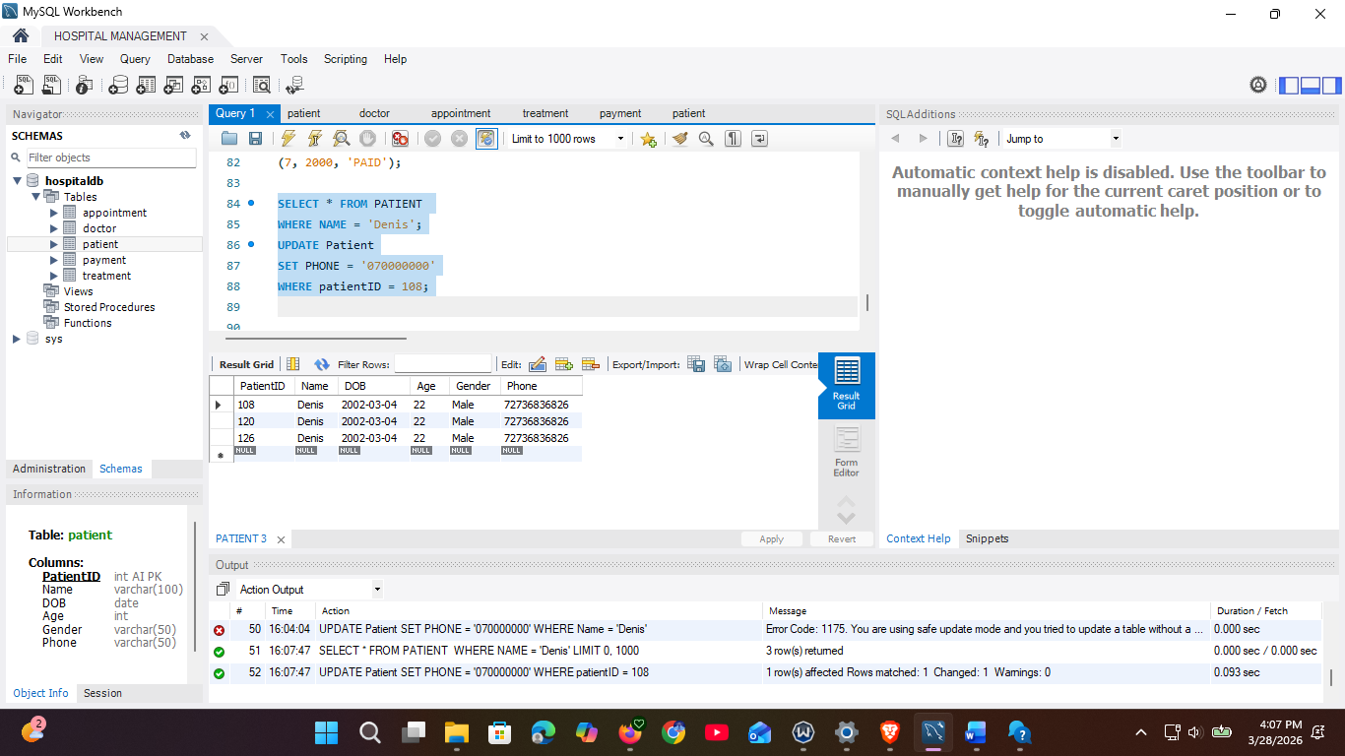
4.4 USE OF DELETE
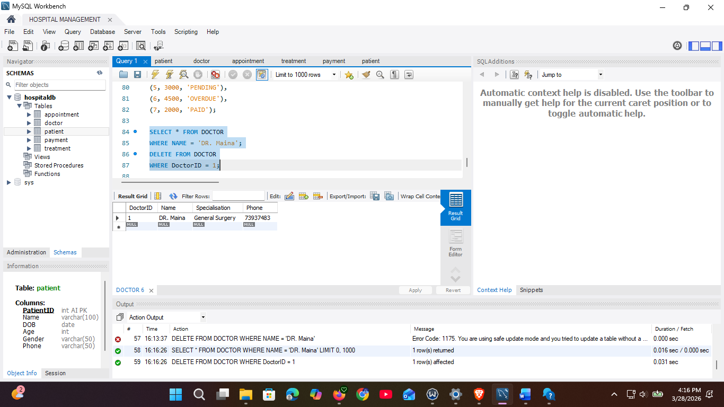

4.5 AGGREGATE ( COUNT)

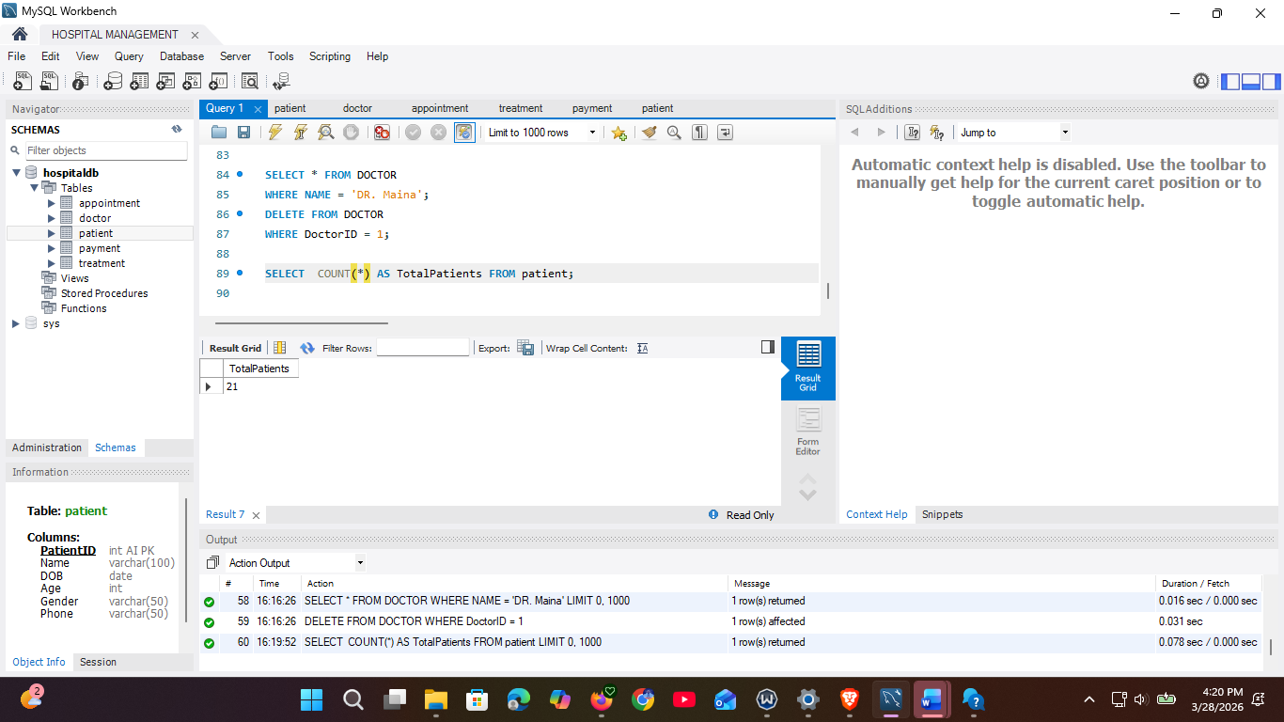
(AVERAGE)
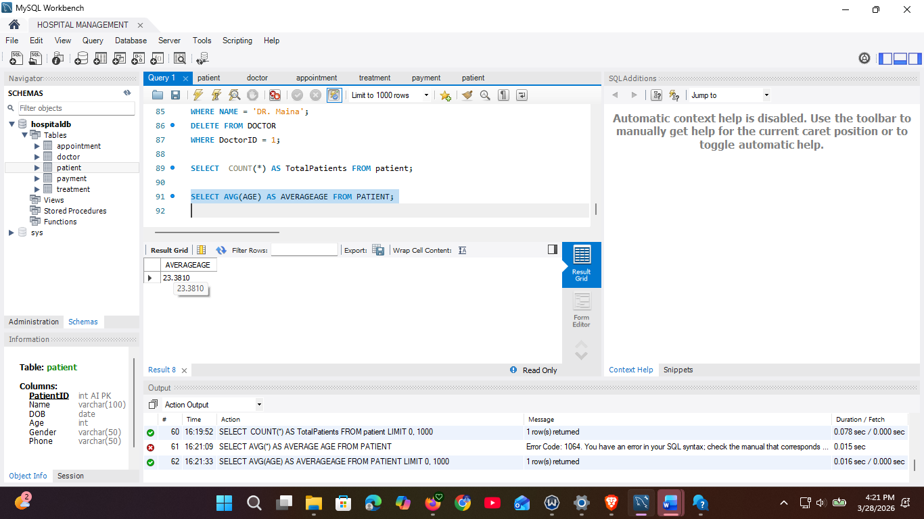

(MAXIMUM)
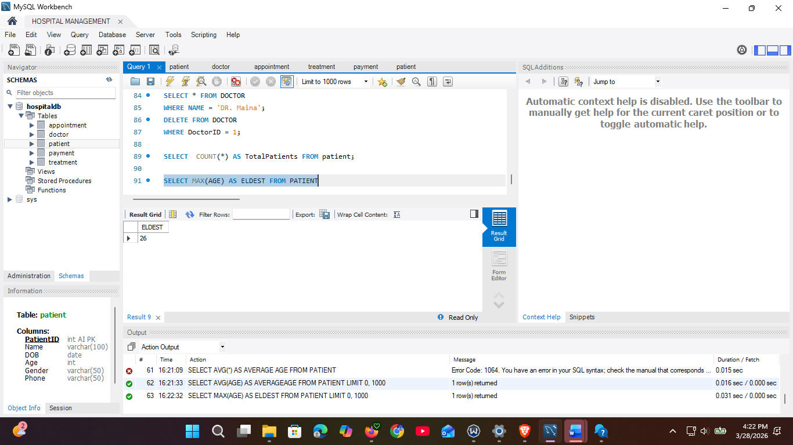
4.6 GROUP BY
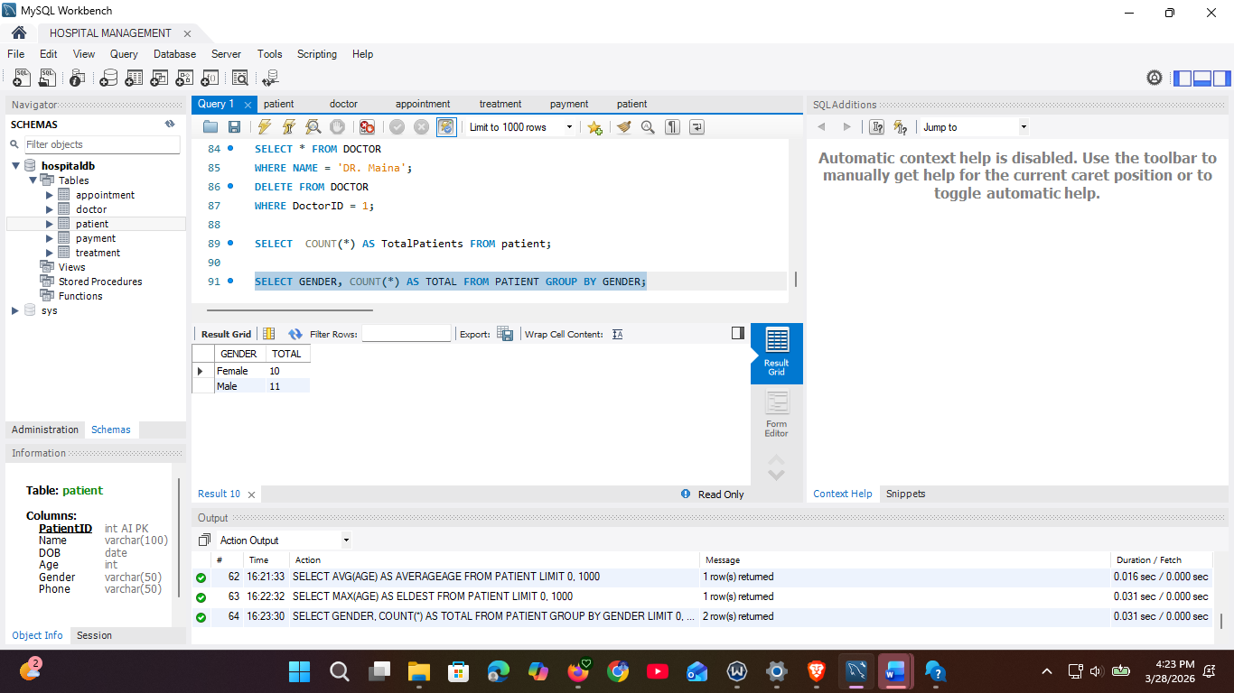
4.7 JOIN
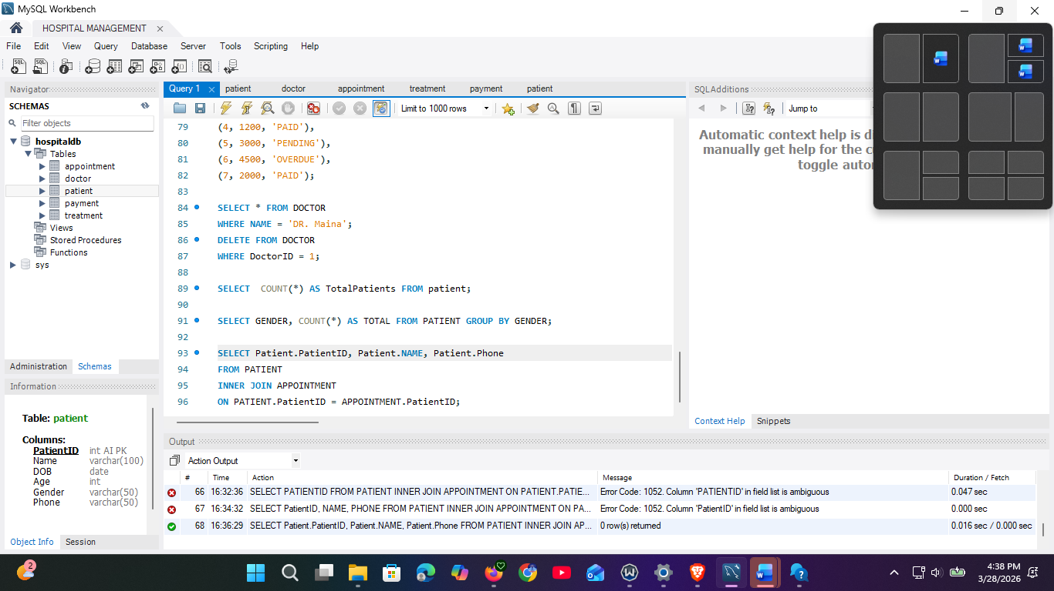

4. Normalization

First Normal Form (1NF)

Payment | PaymentID
Payment | Amount
Payment | Payment status
Patient | PatientID
Patient | Name

Second Normal Form (2NF)
PaymentID | Amount | Payment status | PatientID

PatientID | Name

Third Normal Form (3NF)
PaymentID | Amount | Payment status | PatientID

PatientID | Name

Challenges Encountered
- Defining correct relationships between tables (Patient, Doctor, Appointment)
- Handling foreign keys during data insertion
- SQL errors when writing JOIN queries
- Safe update mode blocking UPDATE and DELETE
- Ensuring matching IDs across related tables

System Efficiency
- Data stored in separate tables reduces redundancy
- Primary and foreign keys maintain data integrity
- Queries allow fast retrieval of records
- Easy to update and manage data
- Supports future expansion

